**EGR 302 – Engineering Design and Documentation**

**Deliverable 5: Design Architecture**

Team Name: _____________RPMs_____________

Team Members: ___________Jordan Ziegler________

___________Timothy Decious______

___________Brian Ungermann______

___________Austin Hulen__________

___________Joshua Hemsley_______

___________Dylan Shanahan_______

Client’s Name: _________Dr. Xu _________________

Version: _________Version 2_______________

Date: _________March 12, 2014

5.1 Mechanical Architecture

5.1.1 Mechanical concept Diagram

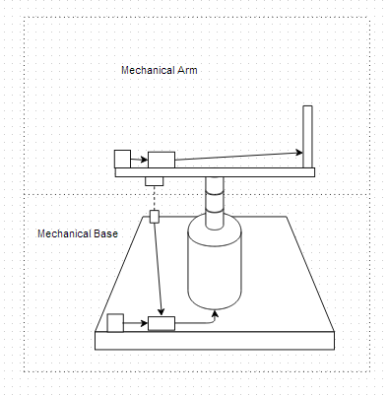

Figure 5.1.1 - Mechanical Concept Diagram for Design Architecture

Figure 5.1.1 demonstrates our concept for the Mechanical Design. The design shows the overall design of our project. There are two basic blocks to this diagram: the arm and the base (found in design below).

5.1.2 Arm Architecture

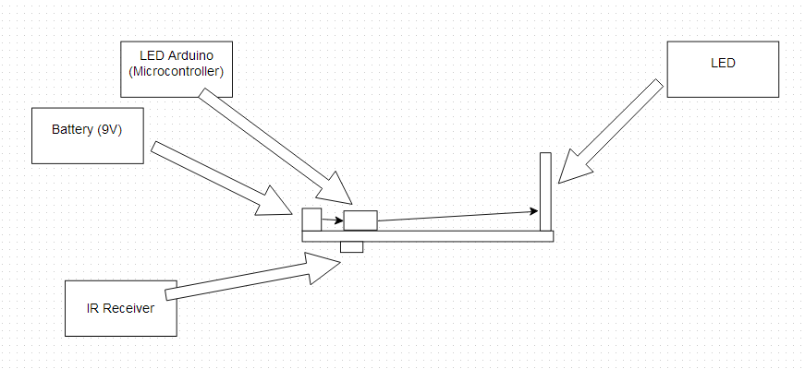

Figure 5.1.2 - Mechanical Arm for Design Architecture

Figure 5.1.2 shows the Arm of the project. This diagram shows that the arm will have the LED Wand on one side of the arm while the IR Receiver, Battery (Arm), and LED Arduino are on the other side. This also shows the flow from one component to the other showing the battery powers the arduino which then controls, and powers, the LEDs.

5.1.3 Base Architecture

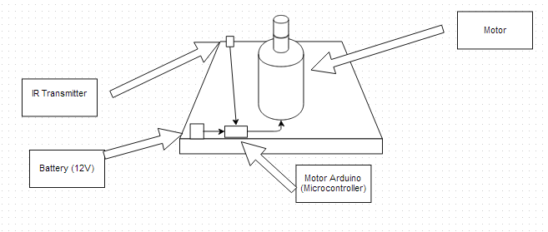

Figure 5.1.2 - Mechanical Base for Design Architecture

Figure 5.1.2 shows the Base of the project. This diagram shows that the Base will house the Motor, the Motor Arduino, the Battery (Motor), and the IR Transmitter. As with the Arm diagram this one shows the flow of power and control. The battery powers the arduino which then controls the speed of the motor and controls the IR Transmitter, which collects data based on the speed of the arm, and sends it back to the arduino.

5.2 Electrical Architecture

5.2.1 Level 0 electrical Architecture

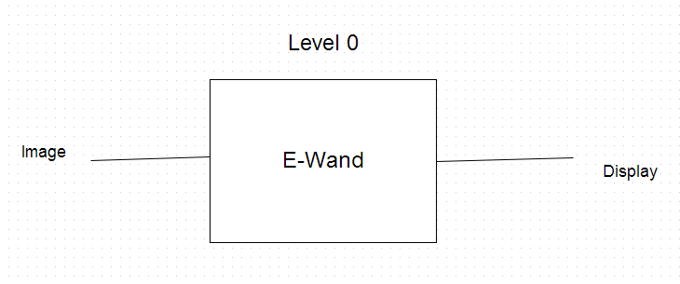

Figure 5.1 - Level 0 layout for Design Architecture

Figure 5.2.1 demonstrates our Level 0 modular design architecture. The architecture is fairly basic, only consisting of the main module. The image is transferred from the user into our product, the E-Wand, and our project outputs the desired display. The module and its inputs are described in detail in the section below.

5.2.2 Level 0 Module Information

|  |  |
| --- | --- |
| *Module* | E-Wand |
| *Inputs* | - User Control: on/off  - Image(any format, size, etc) |
| *Outputs* | Complete display including rotation and flashing LEDs |
| *Functionality* | Receives an image and displays it in a cylindrical format that can be used for advertisement and as a signal for help. |

Table 5.1: E-Wand module information

The E-Wand will first accept an input of an image file. The module accepts the inputs and outputs the outputs described in Table 5.1. After accepting the user input the E-Wand will recognize that it has an input and translate that into a cylindrical display that accurately reflects the desired image.

5.2.3 Level 1 Architecture

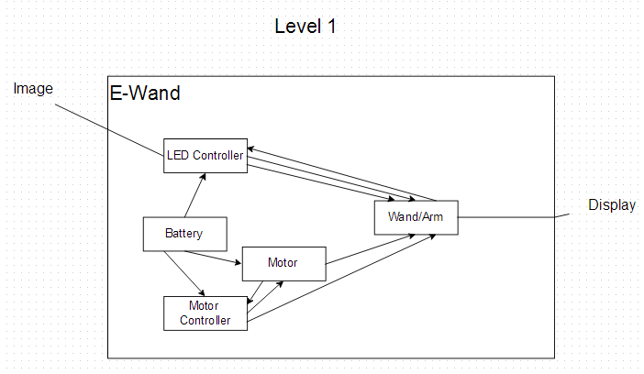

Figure 5.2 - Level 1 layout for Design Architecture

Figure 5.2.3 demonstrates our Level 1 modular design architecture. The architecture is basic but more complicated than Level 0 which only consisted of the main module. The level 1 modules include the controller, battery, motor and arm. The battery powers the controller and the motor. The user’s image is sent to the controller which transfers it to the The motor uses the power to provide torque to the Arm and the controller provides power and direction to the LEDs. The Arm displays the image in the desired cylindrical shape. The modules and their inputs are described in more detail in the section below.

5.2.4 Level 1 Module Information

|  |  |
| --- | --- |
| *Module* | Arduino |
| *Inputs* | -9 volt battery  -Image |
| *Outputs* | -Formatted image to the LEDs |
| *Functionality* | Receives power from 9 Volt battery and an input of the image it is outputting to the Wand/Arm |

Table 5.2: Controller module information

The controller module is the brains of the entire product. The module accepts the inputs and outputs the outputs described in Table 5.2. It requires power from a battery, it also requires an image to be inputted from the user. After the image is processed by the controller it will output to the LED wand to display the image.

|  |  |
| --- | --- |
| *Module* | DC Brushed Motor (model: TRS-775W) |
| *Inputs* | - Battery (12 DCV) |
| *Outputs* | Up to 5500 RPM |
| *Functionality* | Used to rotate the armature |

Table 5.3: DC Brushed Motor Module Information

For Level 1 the DC Brushed Motor that’s being used will accept a battery input of 12 DCV and provide an output of up to 5500 RPM. The module accepts the inputs and outputs the outputs described in Table 5.3. The RPMs are variable based on the input current. It’s assumed to be at max input current from 12 DCV. The output of the motor will provide the spin for the armature which will display the image that was input into the E-Wand.

|  |  |
| --- | --- |
| *Module* | Battery |
| *Inputs* | None |
| *Outputs* | - 12 V for motor  -9V for Controller |
| *Functionality* | Used to power the Motor and IR Sensor |

Table 5.4: Battery Module Information

At Level 1 the battery will have no input. The module outputs the outputs described in Table 5.4. However, it will supply the power that is needed by the motor and the microcontroller. This means the battery will have two outputs.

|  |  |
| --- | --- |
| *Module* | Rotating arm, wand |
| *Inputs* | Torque from motor |
| *Outputs* | -an approximately 45 by 80 cm area for the LEDs to use (45cm wand, 40cm rotating arm)  -force upon the LEDs |
| *Functionality* | Holding the LEDs and revolving the wand carrying them around the center axis |

Table 5.5: Rotating arm, wand information

This portion rotates at high speeds and holds the LEDs, a sensor, a microcontroller, possibly a battery, and wires that connect them. It is important that the rotating arm and wand are made of a strong material that will not easily break like from falling from a car or from merely spinning. The microcontroller and battery will serve as a counterweight to the wand to maintain balance.

5.2.5 Level 2 Architecture

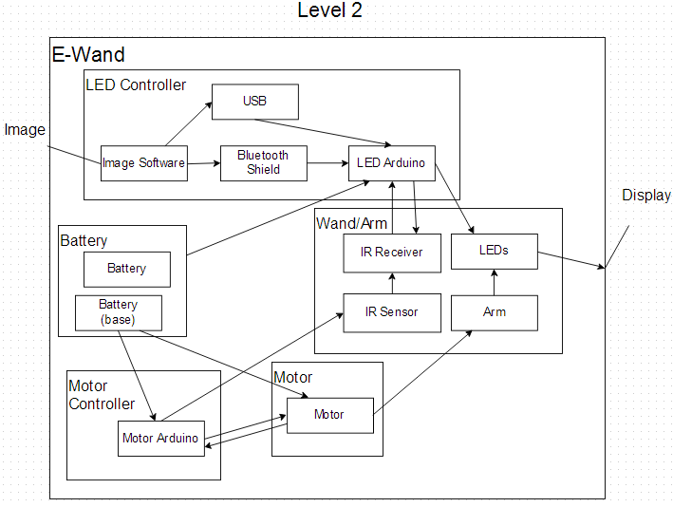

Figure 5.3 - Level 2 layout for Design Architecture

Figure 5.2.5 demonstrates our Level 2 modular design architecture. The architecture is more complex and more specific than Level 1. The modules and their inputs are described in detail in the section below.

5.2.6 Level 2 LED Controller Module

The LED controller module controls the LEDs. It includes the USB module, Arduino, Image software and Bluetooth shield. The LED controller module draws power from the battery module and Infrared sensor information from the IR sensor in the arm module.

5.2.6.1 Level 2 LED Arduino

|  |  |
| --- | --- |
| *Module* | Arduino (Uno) |
| *Inputs* | -9 volt battery  -Bluetooth shield  -Switch  -USB  -IR Receiver |
| *Outputs* | -LED’s |
| *Functionality* | Receive an input of an image from a USB or Bluetooth connection. Also a signal is received from the IR sensors to determine the position of the LED wand and then determines what LEDs to light up. |

Table 5.6 LED Arduino (Uno) Module Information

The LED Arduino is the module that controls the arm circuitry. The arduino accepts the inputs and outputs the outputs described in Table 5.12. This module accepts 5 different inputs and combines them together to provide the LEDs with the information to display the image recorded. The arduino accepts power from the battery to keep it powered, 1 bit from the switch determining whether the system is on or off, and has the ability to accept images from USB or from the bluetooth shield. The Arduino also takes information from the IR sensor and translates it into useful information to ensure the image is properly presented. The output of the Arduino is a signal telling the LEDs which one needs to be turned on at any particular time.

|  |  |
| --- | --- |
| *Module* | Image Software |
| *Inputs* | Image(any format, size, etc) |
| *Outputs* | New image size and format |
| *Functionality* | Receives an image and converts it to the size and format needed and then sends it over Bluetooth or USB to the Arduino |

Table 5.13 Image Software Module Information

The image software is the software that converts an image from a traditional format into a standard format that can be translated into a set of usable information that will then be transmitted to the LEDs through the arduino. The image software module accepts the inputs and outputs the outputs described in Table 5.13.

|  |  |
| --- | --- |
| *Module* | Bluetooth Shield |
| *Inputs* | -Bluetooth signal  -Image |
| *Outputs* | -Bluetooth signal |
| *Functionality* | A connection is made of Bluetooth to send images to the microcontroller, to display on the LED wand |

Table 5.14 Bluetooth Module Information

The Bluetooth accepts the image from the image software and transmits it to the Arduino in the proper format. These Inputs and outputs are shown in Table 5.14. The The bluetooth transmits the data from the computer or ipad wirelessly to the Arduino in a format that the microcontroller will understand and translate for the LEDs.

|  |  |
| --- | --- |
| *Module* | USB |
| *Inputs* | -USB dongle  -Image |
| *Outputs* | -USB dongle |
| *Functionality* | A connection is made with USB cable to send images to the microcontroller, to display on the LED wand |

Table 5.15 USB Module Information

The USB accepts the image from the image software and transmits it to the Arduino in the proper format. The inputs and outputs related to the USB module are shown in Table 5.15. The USB transmits the data from the computer or usb device to the Arduino in a format that the microcontroller will understand and translate for the LEDs.

5.2.7 Level 2 Wand/Arm Module

The wand/arm accepts mechanical force from the motor and display information from the LED controller.The IR sensor The IR receiver module also receives power from the LED controller.

|  |  |
| --- | --- |
| *Module* | DC Brushed Motor (model: TRS-775W) |
| *Inputs* | - User Control: on/off  - Battery (funneled through Switch)  * 12 DCV |
| *Outputs* | Up to 5500 RPM |
| *Functionality* | Used to rotate the armature |

Table 5.6: DC Brushed Motor Module Information

The DC Brushed Motor we are going to use will accept 2 inputs, and provide 1 output. The outputs and inputs the DC Brushed Motor requires are displayed in Table 5.5. The motor is going to accept power from the battery and user control in the form of an on/off switch. When the motor is turned on it will take the power from the battery and generate the circular motion and speed the arm of the LED wand requires.

|  |  |
| --- | --- |
| *Module* | Battery (Base) |
| *Inputs* | None |
| *Outputs* | - 12 V for motor  - 1.5 V for IR Emitter |
| *Functionality* | Used to power the Motor and IR Sensor |

Table 5.7: Battery(base) Module Information

There will be two separate modules that supply power to the system. The module accepts the outputs described in Table 5.6. One of them will supply power to the motor and the IR sensor and the second one will supply it to the arm. This battery module will take no input, but rather simply provide power output to the motor and IR sensor as it is required based on the status of the switch. This battery will be providing 12 volts to the motor based on the motor requirements.

|  |  |
| --- | --- |
| Module | 5mm Infrared Emitter LED |
| Inputs | - voltage range from typical to max (1.45 - 1.65) with current I = 20mA  - max current < 1A |
| Outputs | - light at a 850nm wavelength |
| Functionality | - Generates constant signal for the photo diode receiver interpret |

Table 5.8: 5mm Infrared Emitter LED Module Information

The infrared emitter requires approximately 1.5 V and a 20mA current as shown in Table 5.8. A current above 1A can permanently damage the LED. The LED will output light at a wavelength of 850nm for the photo diode to receive.

|  |  |
| --- | --- |
| Module | Side look Photodiode Receiver |
| Inputs | - Bandwidth wavelength range (840 - 1100)nm  - Wavelength peak sensitivity = 940nm  - 1.5 V |
| Outputs | - Open circuit voltage = 0.35V  - Short circuit current = 18uA |
| Functionality | - Sensor used to detect the IR LED signal when |

Table 5.9: Side look Photodiode Receiver Module Information

The Photodiode Receiver accepts an input from the IR Emitter. This input is in the form of bandwidth wavelength. This can be seen in Table 5.7. The receiver will then send an output to the microcontroller in the form of a small voltage pulse.

|  |  |
| --- | --- |
| *Module* | On/Off switch |
| *Inputs* | - max current DC < 21A  - max voltage DC < 14V  - physically flipping the switch |
| *Outputs* | - Turns into a short-circuit when on  - Turns into an open-circuit when off |
| *Functionality* | - Turns on everything that needs power. |

Table 5.10: On/Off Switch Module Information

The on/off switch is used to connect the battery to each module that that requires power. An on/off switch is needed to simply power up the device. A remote power on is less safe and not as simple for the purpose that this switch is used. The switch also prevents the need of another microcontroller or more complex device that would.

|  |  |
| --- | --- |
| *Module* | Battery (Arm) |
| *Inputs* | None |
| *Outputs* | - 9V for Microcontroller (through switch)  - 9V for the LEDs  - 1.5 V for IR Receiver |
| *Functionality* | Used to power the Microcontroller and LEDs |

Table 5.11: Battery(arm) Module Information

There will be two separate modules that supply power to the system. The module accepts the inputs and outputs the outputs described in Table 5.11. One of them will supply power to the motor and the IR sensor and the second one will supply it to the arm. This battery module will take no input, but rather simply provide power output to the arduino and LEDs as it is required based on the status of the switch and the circuitry. This battery will be providing 9 volts to the arduino because the arduino operates most consistently at that voltage.

|  |  |
| --- | --- |
| *Module* | Image Software |
| *Inputs* | Image(any format, size, etc) |
| *Outputs* | New image size and format |
| *Functionality* | Receives an image and converts it to the size and format needed and then sends it over Bluetooth or USB to the Arduino |

Table 5.13 Image Software Module Information

The image software is the software that converts an image from a traditional format into a standard format that can be translated into a set of usable information that will then be transmitted to the LEDs through the arduino. The image software module accepts the inputs and outputs the outputs described in Table 5.13.

|  |  |
| --- | --- |
| *Module* | Bluetooth Shield |
| *Inputs* | -Bluetooth signal  -Image |
| *Outputs* | -Bluetooth signal |
| *Functionality* | A connection is made of Bluetooth to send images to the microcontroller, to display on the LED wand |

Table 5.14 Bluetooth Module Information

The Bluetooth accepts the image from the image software and transmits it to the Arduino in the proper format. These Inputs and outputs are shown in Table 5.14. The The bluetooth transmits the data from the computer or ipad wirelessly to the Arduino in a format that the microcontroller will understand and translate for the LEDs.

|  |  |
| --- | --- |
| *Module* | LEDs |
| *Inputs* | -3.0 V needed for each  -three input pins, one for each color  -one ground pin  -data from the MCU that  determines the status of input pins  - input current below 20mA |
| *Outputs* | - 12000-14000 mcd intensity light  -blue, red, or green light or a combination in a concise image |
| *Functionality* | Creates visible images for the display |

Table 5.19: LEDs Module Information

The LEDs are probably along with the power, the most important part of the product. Without any light the product cannot fulfill its primary function as a display. The LEDs accept inputs and outputs as described in Table 5.19. The LED module The LEDs that will be used for this product are high brightness RGBs. Between 30-100 will be used for this product. The LEDs will be directed by the other modules to produce the desired display.

|  |  |
| --- | --- |
| *Module* | Rotating arm, wand |
| *Inputs* | Torque from motor |
| *Outputs* | -an approximately 45 by 80 cm area for the LEDs to use (45cm wand, 40cm rotating arm)  -force upon the LEDs |
| *Functionality* | Holding the LEDs and revolving the wand carrying them around  the center axis |

Table 5.20: Rotating Arm/Wand Module Information

This portion rotates at high speeds and holds the LEDs, a sensor, a microcontroller, possibly a battery, and wires that connect them. It is important that the rotating arm and wand are made of a strong material that will not easily break like from falling from a car or from merely spinning. The microcontroller and battery will serve as a counterweight to the wand to maintain balance.

**5.3 Software Flow Diagram**

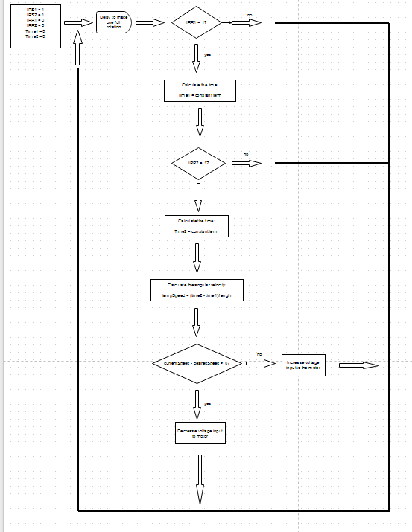

Figure 5.4 Flow diagram

This Figure shows the way the software controls the LEDs based on position.